Get Ready Guide
May 24th, 2026
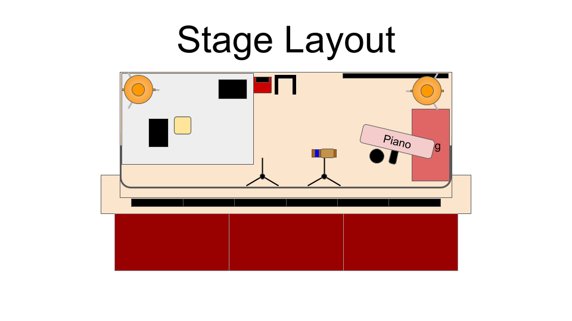
Expected Platform Team

BAND (SATURDAY 14:30 CALL)
- [Name | First-name Last Initial]: AC Gui or Keys
- [Name | First-name Last Initial]: Drums
- [Name | First-name Last Initial]: Keys

CHOIR (SUNDAY 7:30 CALL)
- [Name | First-name Last Initial]: WL
- [Name | First-name Last Initial]: Part Lead

ALL TEAM TECH RUN SUNDAY 08:00 CALL

Song List (Check PCO For Keys):

- Key of D: The Joy - The Belonging Co.
- Key of C: More Than Able - Mav City
- Key of C: Trust In God - Elevation
- Key of A: Build My Life - Pat Barrett

The Joy
By: Andrew Holt | Mitch Wong
© Andrew Holt Music Publishing | TBCO Publishing | A Wong Made Write Publishing | Integrity's Praise! Music
CCLI License #42373, CCLI Song #7209419

4 Bar Intro (ft. Keys)

8 Bar Intro (ft. Full Band)

VERSE 1: Insert Name
This is the day You made

So I’ll rejoice and be glad
Rejoice and be glad in it

VERSE 2: Insert Name
This is where I believe

That You are more than enough
More than enough for me

PRE-CHORUS: Insert Name
You are faithful to Your promise
You are strong when I am weak

When I’m standing in Your presence
I have everything I need

CHORUS: Insert Name + All
The joy of the Lord
The joy of the Lord is my strength

The joy of the Lord
The joy of the Lord is my strength

O my soul bless His Name
All that is within me say

The joy of the Lord
The joy of the Lord is my strength

4 Bar Interlude (ft. Drums, Keys & E.G. 1)

VERSE 3: Insert Name + All
Jesus come what may
You are worthy of all

Worthy of all my praise

PRE-CHORUS: Insert Name + All
You are faithful to Your promise
You are strong when I am weak

When I’m standing in Your presence
I have everything I need

CHORUS: Insert Name + All
The joy of the Lord
The joy of the Lord is my strength

The joy of the Lord
The joy of the Lord is my strength

O my soul bless His Name
All that is within me say

The joy of the Lord
The joy of the Lord is my strength

8 Bar Instrumental (ft. Drums, Keys & E.G. 1)

BRIDGE: Insert Name
So let it rise up
Like a river

Overflowing
Holy Spirit

And let it pour out
With no limit

Overflowing
Holy Spirit

BRIDGE: Insert Name + All
So let it rise up
Like a river

Overflowing
Holy Spirit

And let it pour out
With no limit

Overflowing
Holy Spirit

16 Bar Instrumental (ft. Ohs & Drums)

CHORUS: Insert Name + All
The joy of the Lord
The joy of the Lord is my strength

The joy of the Lord
The joy of the Lord is my strength

O my soul bless His Name
All that is within me say

TAG 1: Insert Name + All
O my soul bless His Name
All that is within me say

TAG 1: Insert Name + All
O my soul bless His Name
All that is within me say

TAG 2: Insert Name + All
O my soul bless His Name
All that is within me say

The joy of the Lord
The joy of the Lord is my strength

END

More Than Able
By: Ben Fielding, Chandler Moore, Naomi Raine & Steven Furtick
© For Humans Publishing (Admin by Essential Music Publishing)Maverick City Publishing (Admin by Essential Music Publishing), Naomi Raine Publishing Designee (Admin by Essential Music Publishing), SHOUT! Music Publishing, Australia (Admin. by Capitol CMG Publishing), Music by Elevation Worship Publishing (Admin. by Essential Music Publishing LLC)
CCLI License # 42373, CCLI Song # 7209590

8 Bar Intro (ft. Keys)

VERSE 1: Insert Name 1
When did I start to forget
All of the great things You did

When did I throw away
Faith for the impossible

How did I start to believe
You weren't sufficient for me

Why do I talk myself
Out of seeing miracles

CHORUS: Insert Name 1
You are more than able

You are more than able

You are more than able

You are more than able

Who am I to deny
What the Lord can do

4 Bar Interlude (ft. Keys)

VERSE 2: Insert Name 2
Now I see all that I have
Oh I've got my confidence back

I put my trust in the

+ Insert Name 1
One who still does miracles

You do miracles

CHORUS: Insert Name 2 + All
You are more than able

You are more than able

You are more than able

You are more than able

Who am I to deny
What the Lord can do

BRIDGE 1: Insert Name 2
Can you imagine
With all of the faith in the room

What the Lord can do
What the Lord can do

It's gonna happen
Just let the Way Maker through

He's gonna move
He's gonna move

BRIDGE 1: Insert Name 2 + All
Can you imagine
With all of the faith in the room

What the Lord can do
What the Lord can do

It's gonna happen
Just let the Way Maker through

He's gonna move
He's gonna move

BRIDGE 1: Insert Name 2 + All
Can you imagine
With all of the faith in the room

What the Lord can do
What the Lord can do

It's gonna happen
Just let the Way Maker through

He's gonna move
He's gonna move

BRIDGE 2: Insert Name 1 + Insert Name 2 + All
Anything is possible

Anything is possible

Anything is possible

Who am I to deny
What the Lord can do

BRIDGE 2: Insert Name 1 + Insert Name 2 + All
Anything is possible

Anything is possible

Anything is possible

Who am I to deny
What the Lord can do

BRIDGE 2: Insert Name 1 + Insert Name 2 + All
Anything is possible

Anything is possible

Anything is possible

Who am I to deny
What the Lord can do

TAG: Insert Name 1 + Insert Name 2 + All
Who am I to deny
What the Lord can do

Who am I to deny
What the Lord can do

4 Bar Interlude (ft. Keys)

CHORUS: Insert Name 2 + All
You are more than able

You are more than able

You are more than able

You are more than able

Who am I to deny
What the Lord can do

END

Trust In God
By: Brandon Lake, Chris Brown, Mitch Wong & Steven Furtick
© Brandon Lake Music (Admin by Essential Music Publishing)
Maverick City Publishing Worldwide (Admin by Essential Music Publishing)
Music by Elevation Worship Publishing (Admin. by Essential Music Publishing LLC)
Remaining portion is unaffiliated
CCLI License # 42373, CCLI Song # 7206001

8 Bar Intro (ft. Keys)

VERSE 1: Insert Name
Blessed assurance
Jesus is mine

He's been my fourth man in the fire
Time after time

Born of His Spirit
Washed in His blood

And what He did for me on Calvary
Is more than enough

CHORUS: Insert Name + All
I trust in God
My Savior

The One who will never fail
He will never fail

CHORUS: Insert Name + All
I trust in God
My Savior

The One who will never fail
He will never fail

2 Bar Hold

VERSE 2: Insert Name + All
Perfect submission
All is at rest

I know the author of tomorrow
Has ordered my steps

So this is my story
And this is my song

I’m praising my risen King and Savior
All the day long

CHORUS: Insert Name + All
I trust in God
My Savior

The One who will never fail
He will never fail

CHORUS: Insert Name + All
I trust in God
My Savior

The One who will never fail
He will never fail

8 Bar Interlude (ft. Keys)

BRIDGE: Lead Name
I sought the Lord and He heard
And He answered

I sought the Lord and He heard
And He answered

I sought the Lord and He heard
And He answered

That’s why I trust Him

That’s why I trust Him

BRIDGE: Insert Name + All
I sought the Lord and He heard
And He answered

I sought the Lord and He heard
And He answered

I sought the Lord and He heard
And He answered

That’s why I trust Him
That’s why I trust Him

BRIDGE: Insert Name + All
I sought the Lord and He heard
And He answered

I sought the Lord and He heard
And He answered

I sought the Lord and He heard
And He answered

That’s why I trust Him
That’s why I trust Him

BRIDGE: Insert Name + All
I sought the Lord and He heard
And He answered

I sought the Lord and He heard
And He answered

I sought the Lord and He heard
And He answered

That’s why I trust Him
That’s why I trust Him

CHORUS: Insert Name + All
I trust in God
My Savior

The One who will never fail
He will never fail

CHORUS: Insert Name + All
I trust in God
My Savior

The One who will never fail
He will never fail

BRIDGE: Insert Name + All
I sought the Lord and He heard
And He answered

I sought the Lord and He heard
And He answered

I sought the Lord and He heard
And He answered

That’s why I trust Him
That’s why I trust Him

BRIDGE: Insert Name + All
I sought the Lord and He heard
And He answered

I sought the Lord and He heard
And He answered

I sought the Lord and He heard
And He answered

That’s why I trust Him
That’s why I trust in God

16 Bar Interlude (ft. Full Band)

CHORUS: Insert Name
I trust in God
My Savior

The One who will never fail
He will never fail

CHORUS: Insert Name
I trust in God
My Savior

The One who will never fail
He will never fail

END

Build My Life
By: Brett Younker, Karl Martin, Kirby Elizabeth Kaple, Matt Redman, and Pat Barrett
© 2016 Martin, Karl Josh (Admin. by Arkyard Music Services Limited), Kaple Music (Admin. by Bethel Music Publishing), Capitol CMG Genesis (Admin. by Capitol CMG Publishing), Housefires Sounds (Admin. by Capitol CMG Publishing), Said And Done Music (Admin. by Capitol CMG Publishing), sixsteps Music (Admin. by Capitol CMG Publishing), Thankyou Music (Admin. by Capitol CMG Publishing), worshiptogether.com songs (Admin. by Capitol CMG Publishing), Bethel Music Publishing
CCLI License #42373, CCLI Song # 7070345

4 Bar Intro (ft. A.G. & Keys)

VERSE 1: Insert Name
Worthy of every song
We could ever sing

Worthy of all the praise
We could ever bring

Worthy of every breath
We could ever breathe

We live for You

VERSE 2: Insert Name
Jesus
The name above every other name

Jesus
The only one who could ever save

You’re worthy of every breath
We could ever breathe

We live for You
We live for You

CHORUS: Insert Name + All
Holy
There is no one like You

There is none beside You
Open up my eyes in wonder
Show me
Who You are

And fill me
With Your heart

And lead me
In Your love to those around me

VERSE 1: Insert Name + All
Worthy of every song
We could ever sing

Worthy of all the praise
We could ever bring

Worthy of every breath
We could ever breathe

We live for You

VERSE 2: Insert Name + All
Jesus
The name above every other name

Jesus
The only one who could ever save

You’re worthy of every breath
We could ever breathe

We live for You
We live for You

CHORUS: Insert Name + All
Holy
There is no one like You

There is none beside You
Open up my eyes in wonder

Show me
Who You are

And fill me
With Your heart

And lead me
In Your love to those around me

CHORUS: Insert Name + All
Holy
There is no one like You

There is none beside You
Open up my eyes in wonder

Show me
Who You are

And fill me
With Your heart

And lead me
In Your love to those around me

8 Bar Interlude (ft. E.G. & Keys)

BRIDGE: Insert Name + All
I will build my life
Upon Your love

It is a firm foundation

I will put my trust
In You alone

And I will not be shaken

BRIDGE: Insert Name + All
I will build my life
Upon Your love

It is a firm foundation

I will put my trust
In You alone

And I will not be shaken

BRIDGE: Insert Name + All
I will build my life
Upon Your love

It is a firm foundation

I will put my trust
In You alone

And I will not be shaken

CHORUS: Insert Name + All
Holy
There is no one like You

There is none beside You
Open up my eyes in wonder

Show me
Who You are

And fill me
With Your heart

And lead me
In Your love to those around me

CHORUS: Insert Name + All
Holy
There is no one like You

There is none beside You
Open up my eyes in wonder

Show me
Who You are

And fill me
With Your heart

And lead me
In Your love to those around me

END

